**A mini-project on AWS SNS(Simple Notification Service)**

We'll create a simple notification system that sends notifications via email whenever a new message is published to an SNS topic.

**Step 1: Set Up Your AWS Account**

1. **Sign up or Log in:** Ensure you have an AWS account. If you don’t, sign up at [AWS Free Tier](https://aws.amazon.com/free/).
2. **Access AWS Management Console:** Log in to the [AWS Management Console](https://aws.amazon.com/console/).

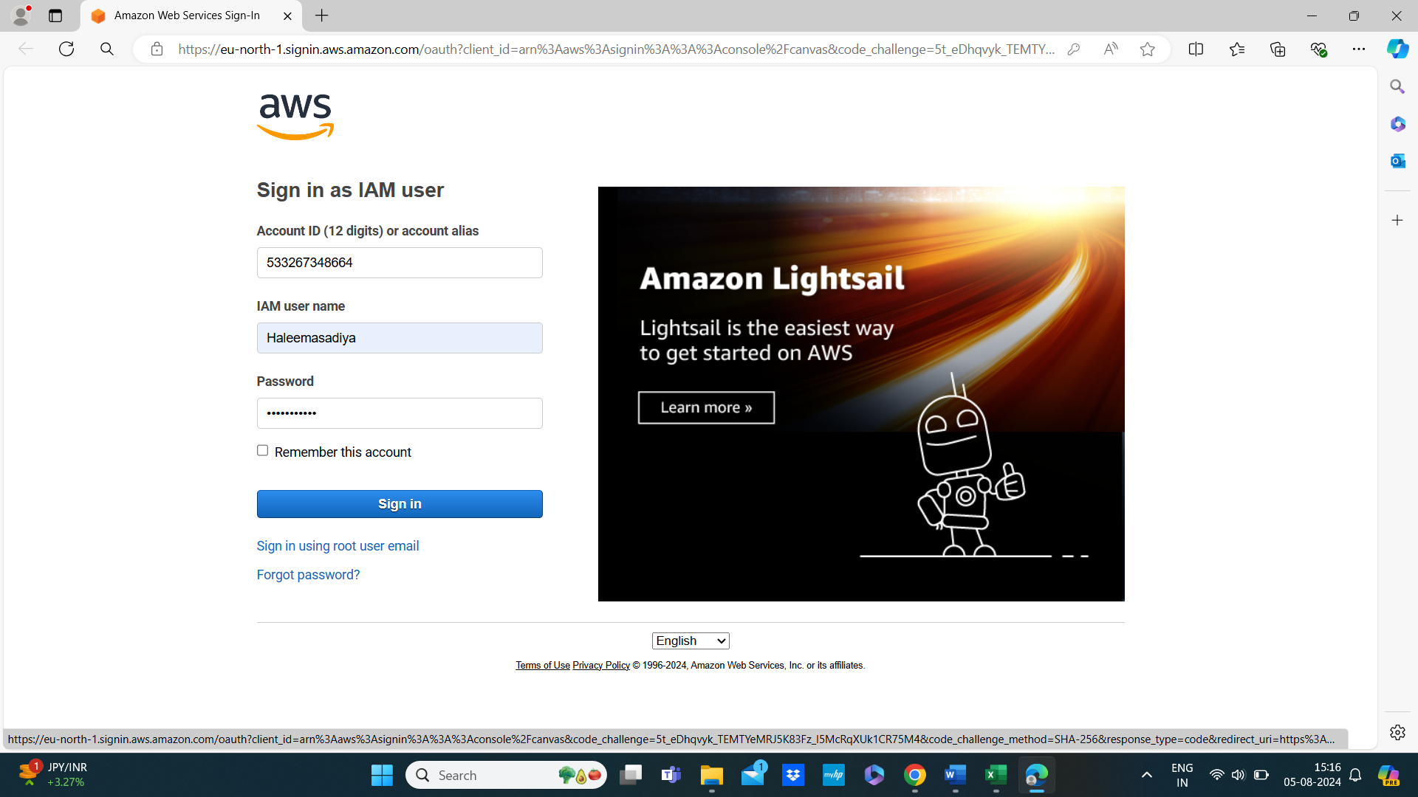

**Step 2: Create an SNS Topic**

1. **Navigate to SNS:**
   * Go to the AWS Management Console.
   * Search for "SNS" in the services search bar and select it.

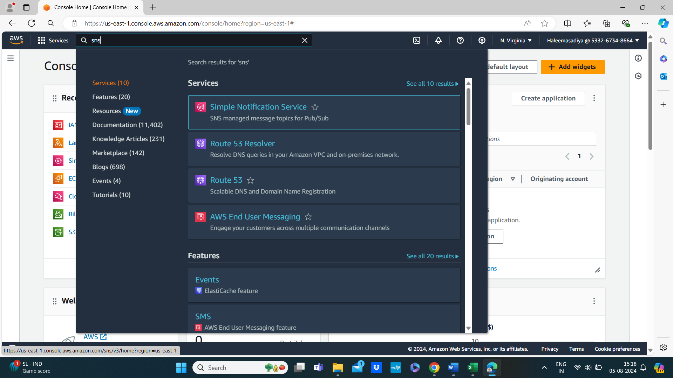

1. **Create a Topic:**
   * Click on “Topics” from the left-hand menu.
   * Click the “Create topic” button.
   * Choose “Standard” or “FIFO” based on your needs. Standard is usually sufficient for most use cases.
   * Enter a “Name” for your topic (e.g., MyNotificationTopic).
   * Optionally, add a display name and tags.
   * Click “Create topic.”

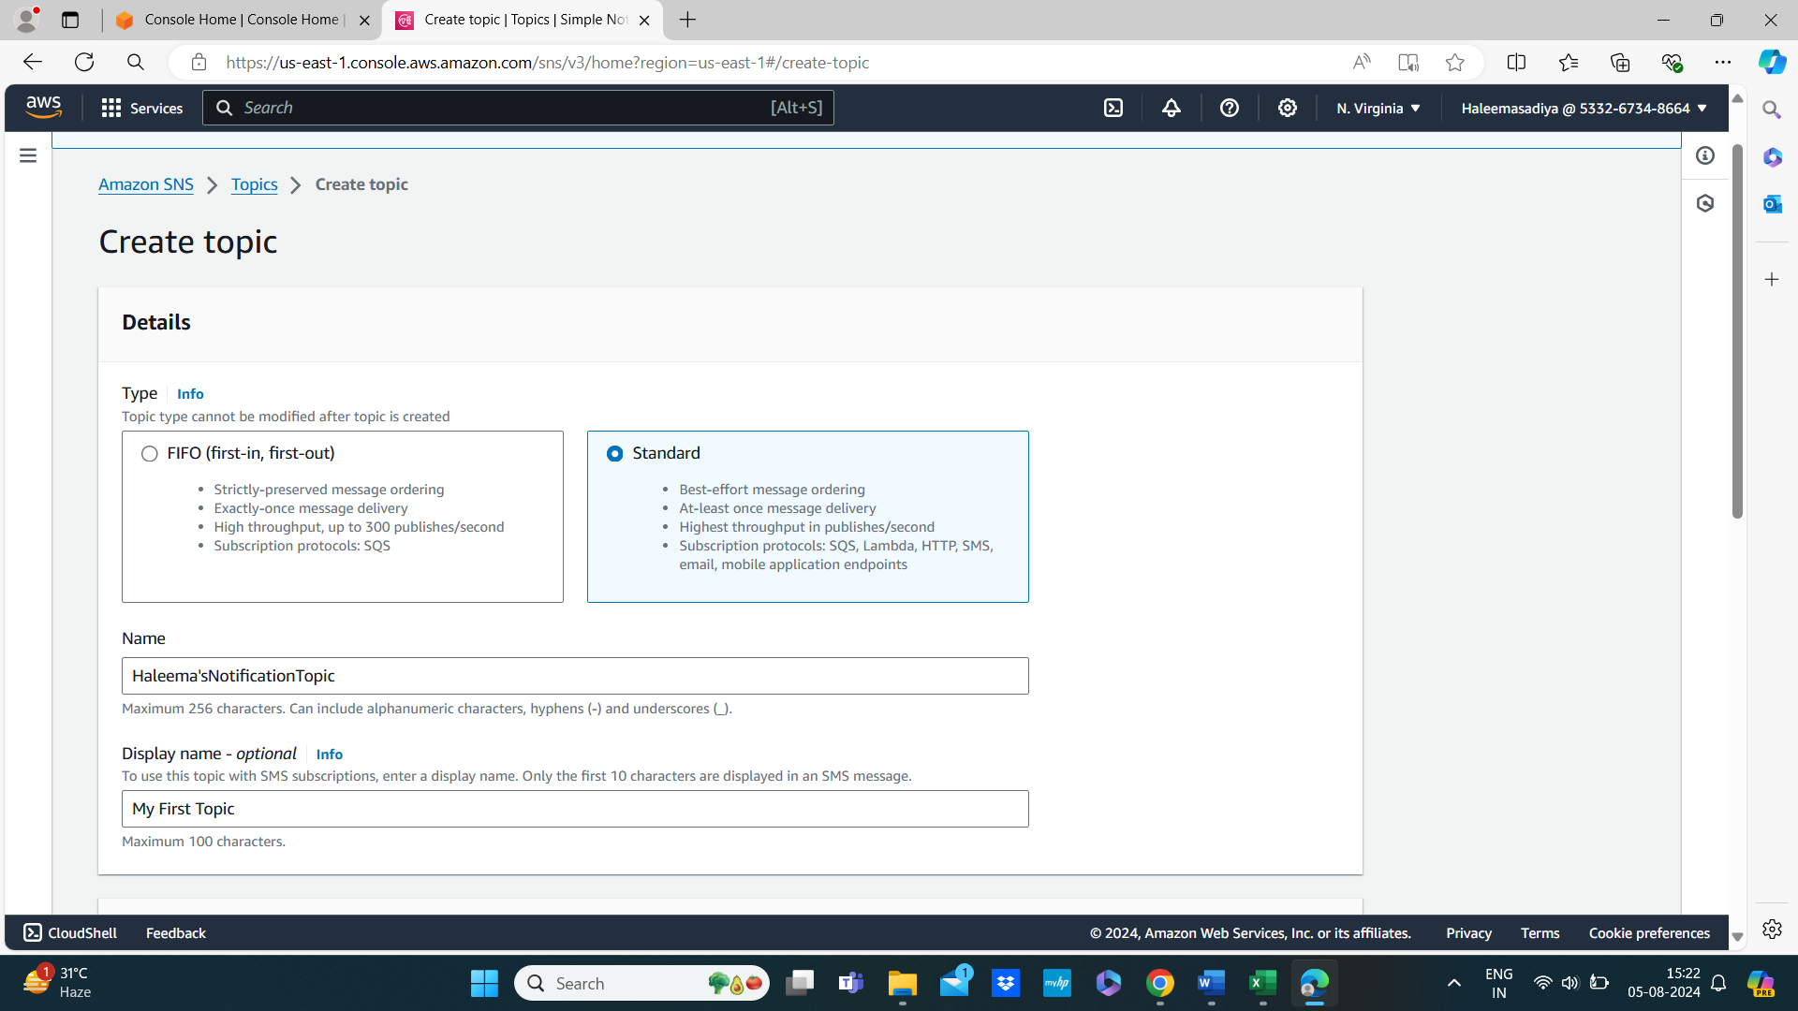

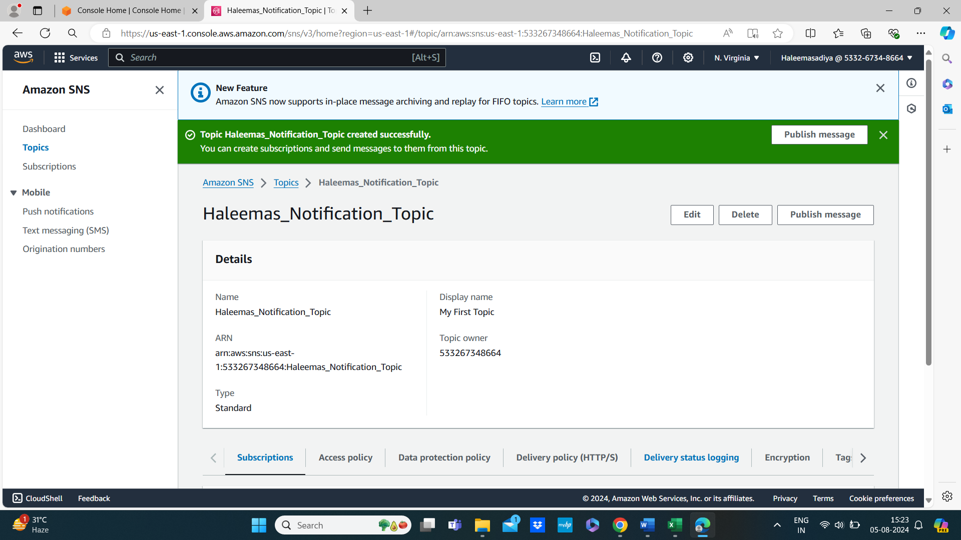

**Step 3: Subscribe to the Topic**

1. **Create a Subscription:**
   * Go to the “Subscriptions” section on the left menu.
   * Click “Create subscription.”
   * For “Protocol,” choose “Email.”
   * For “Endpoint,” enter your email address where you want to receive notifications.
   * Click “Create subscription.”

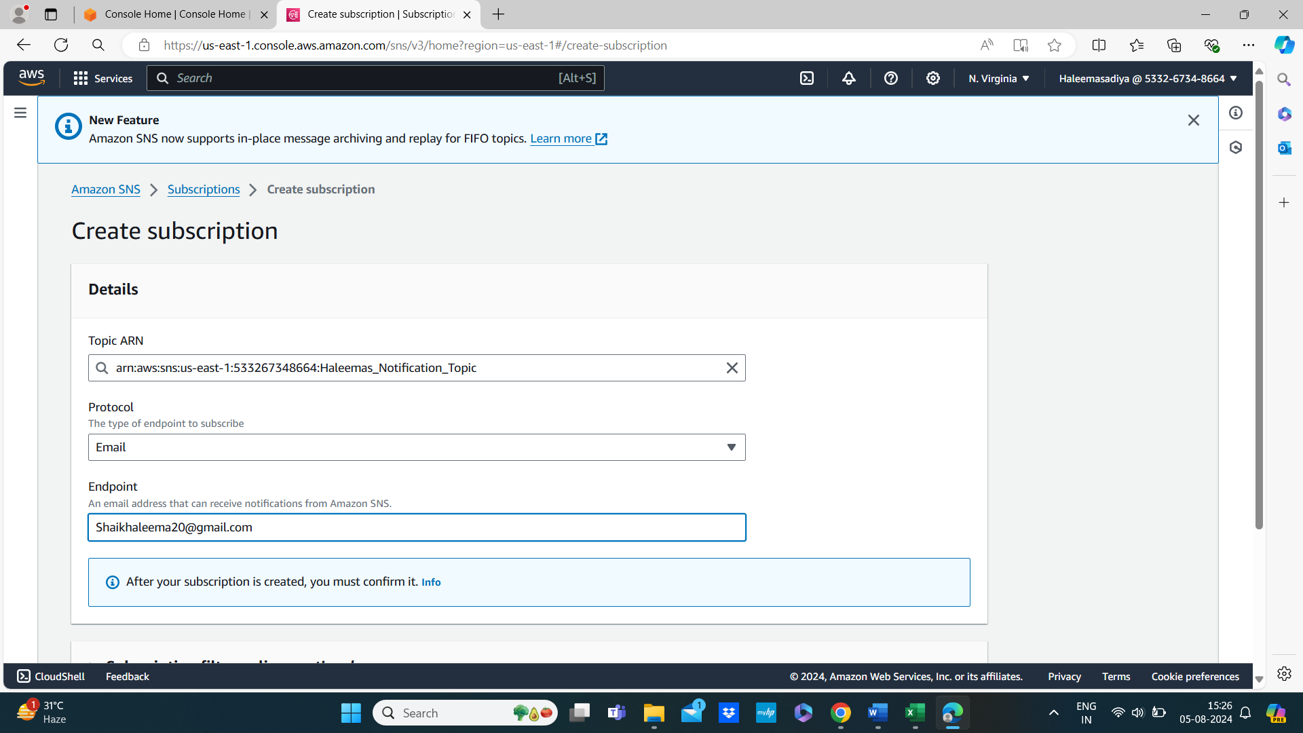

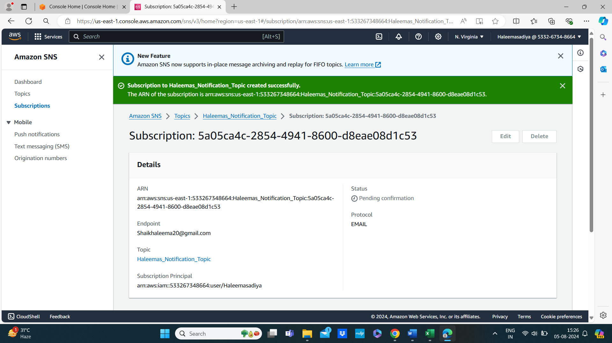

1. **Confirm Subscription:**
   * Check your email for a confirmation message from AWS SNS.

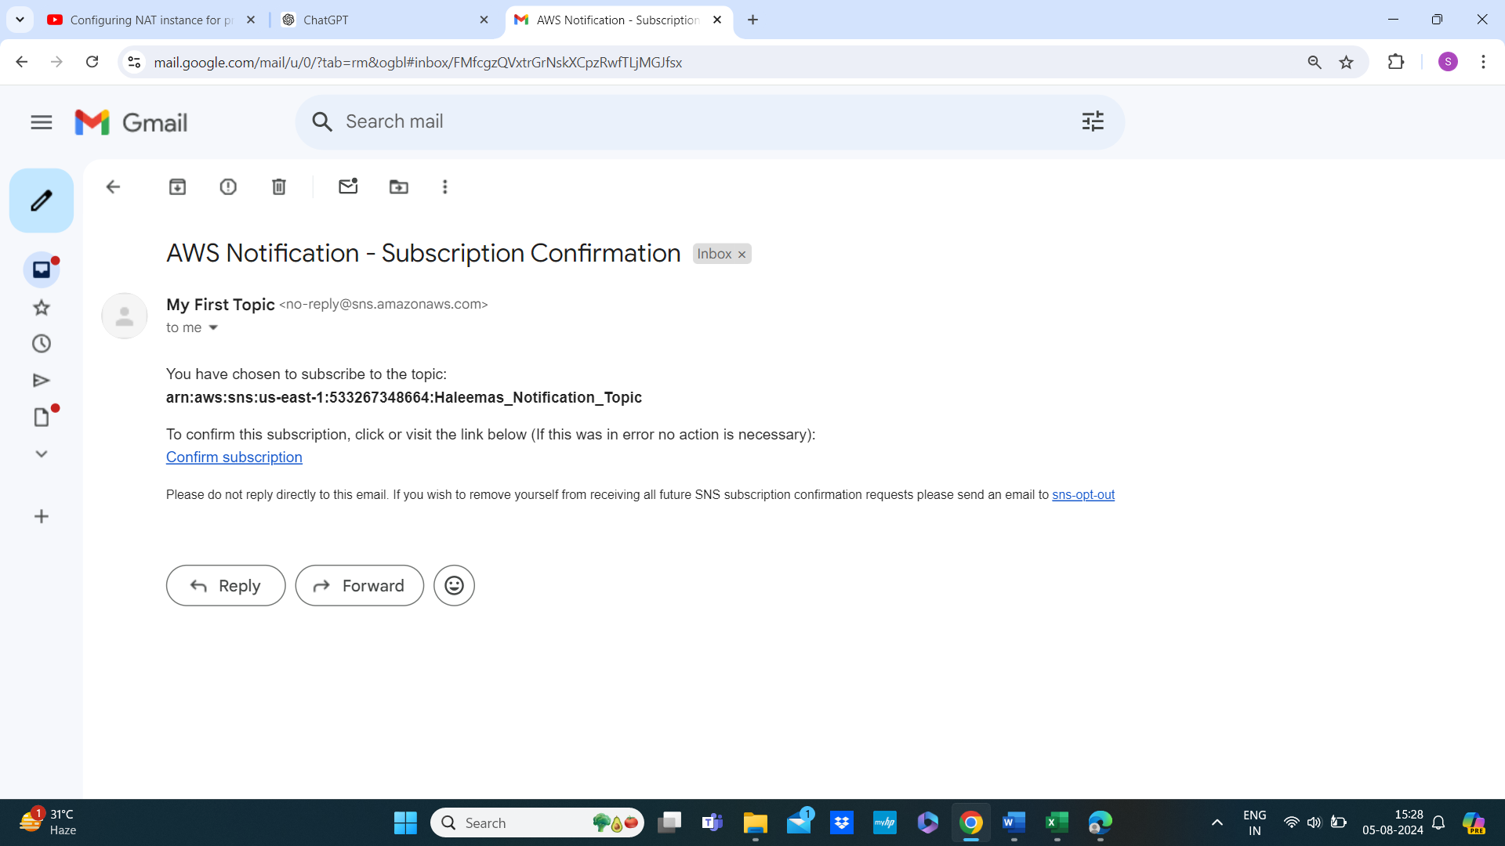

* + Click the confirmation link in the email to confirm your subscription.

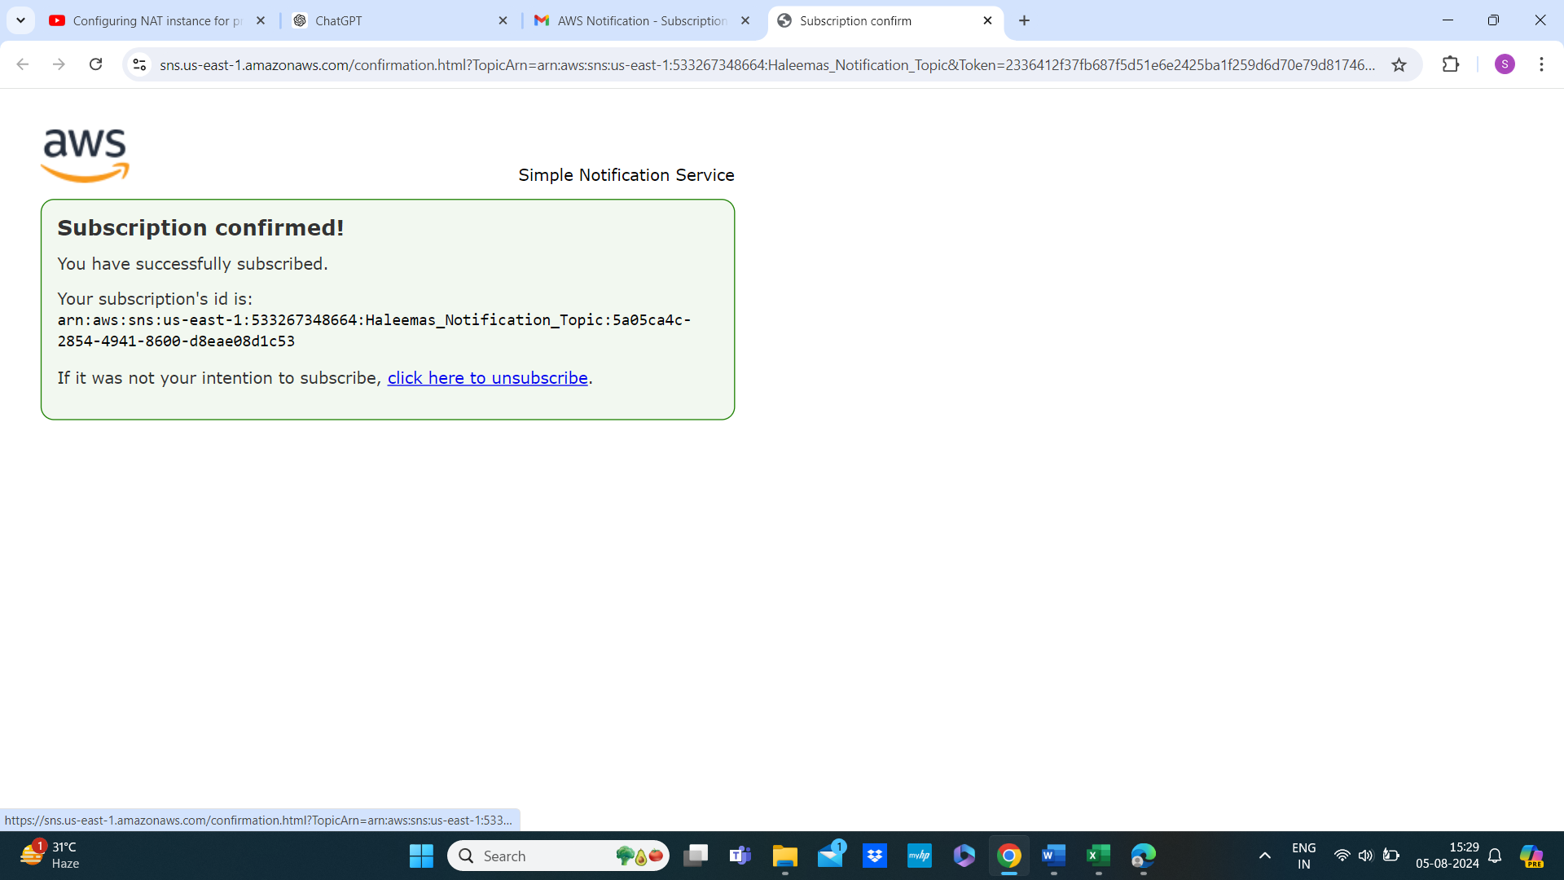

**Step 4: Publish a Message to the Topic**

1. **Go to the Topic Details:**
   * Navigate to the “Topics” section.
   * Click on your topic name (e.g., Haleemas_Notification_Topic).

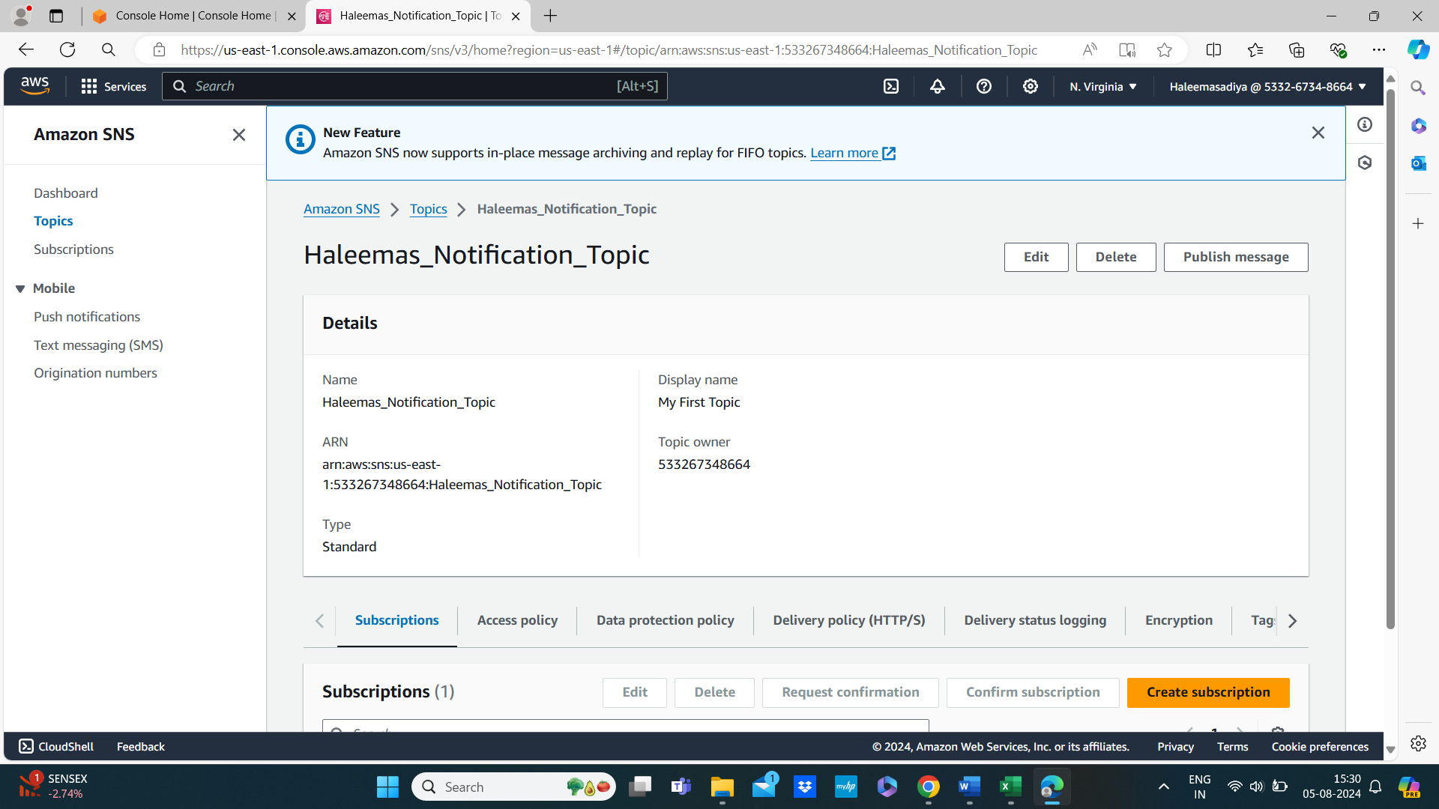

1. **Publish a Message:**
   * Click “Publish message.”
   * Enter a “Subject” and a “Message body” for your notification.
   * Click “Publish message.”

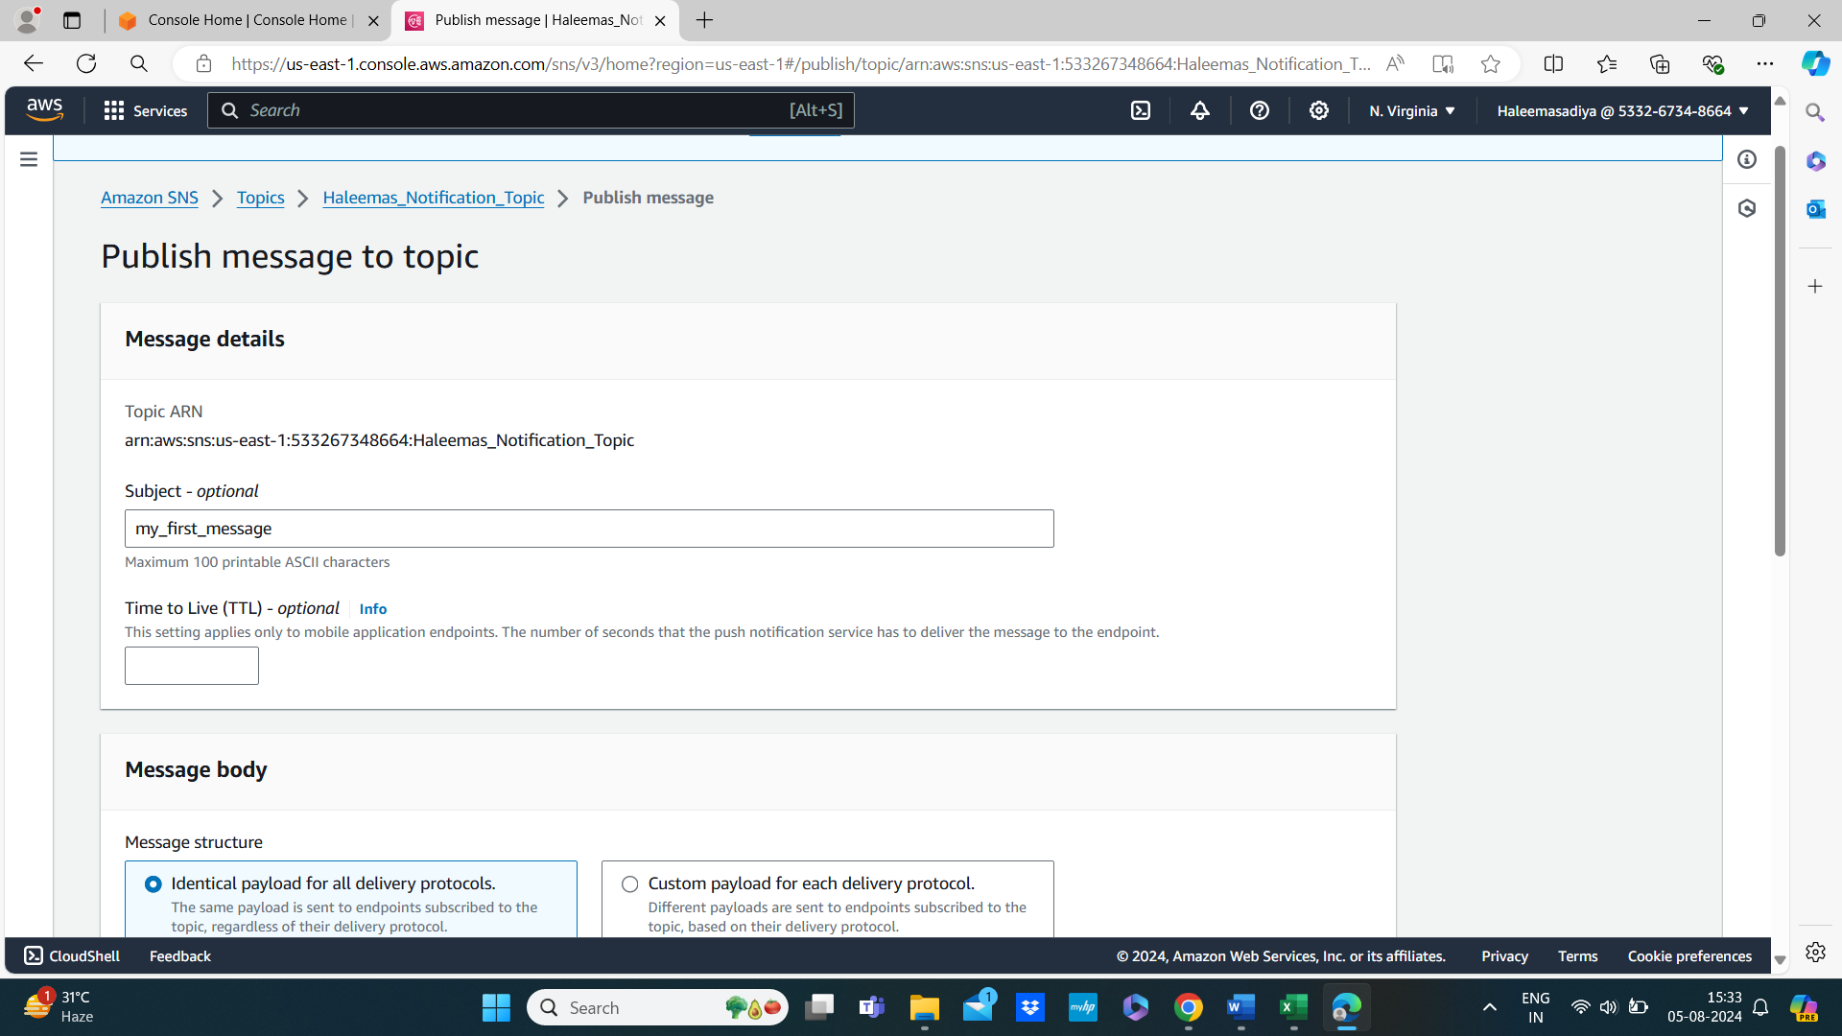

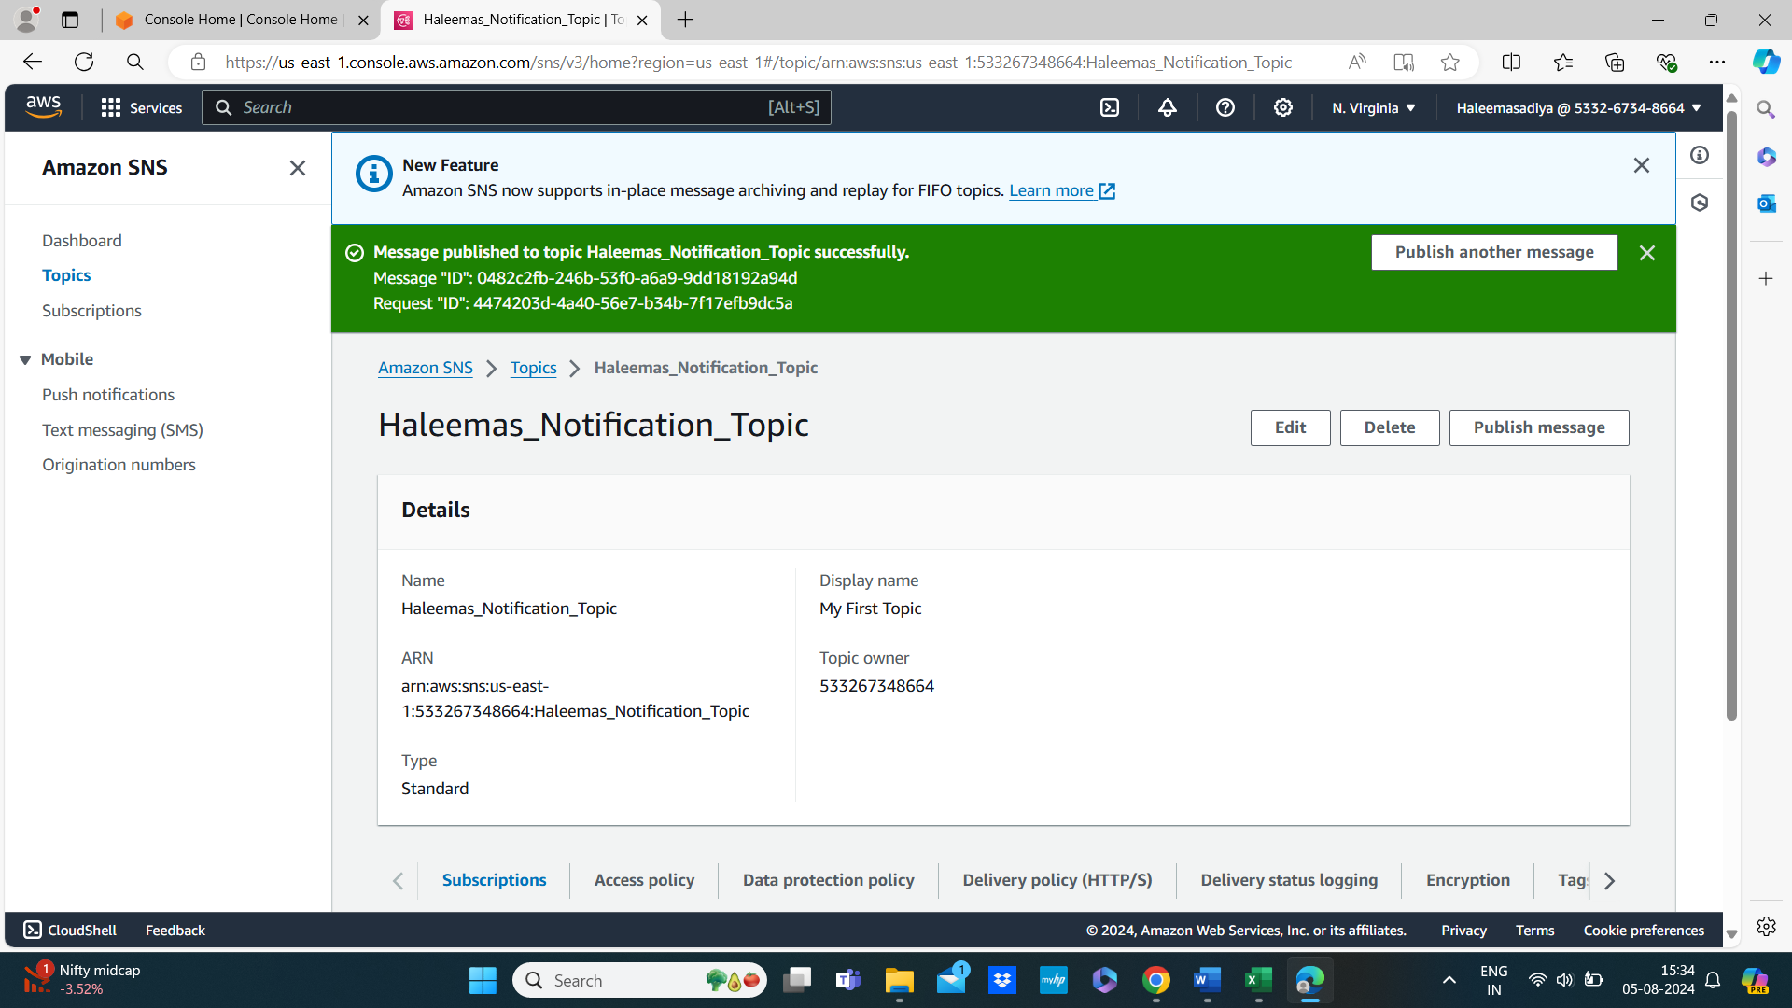

1. **Check Your Email:**
   * Verify that you receive the email notification with the subject and body you specified.

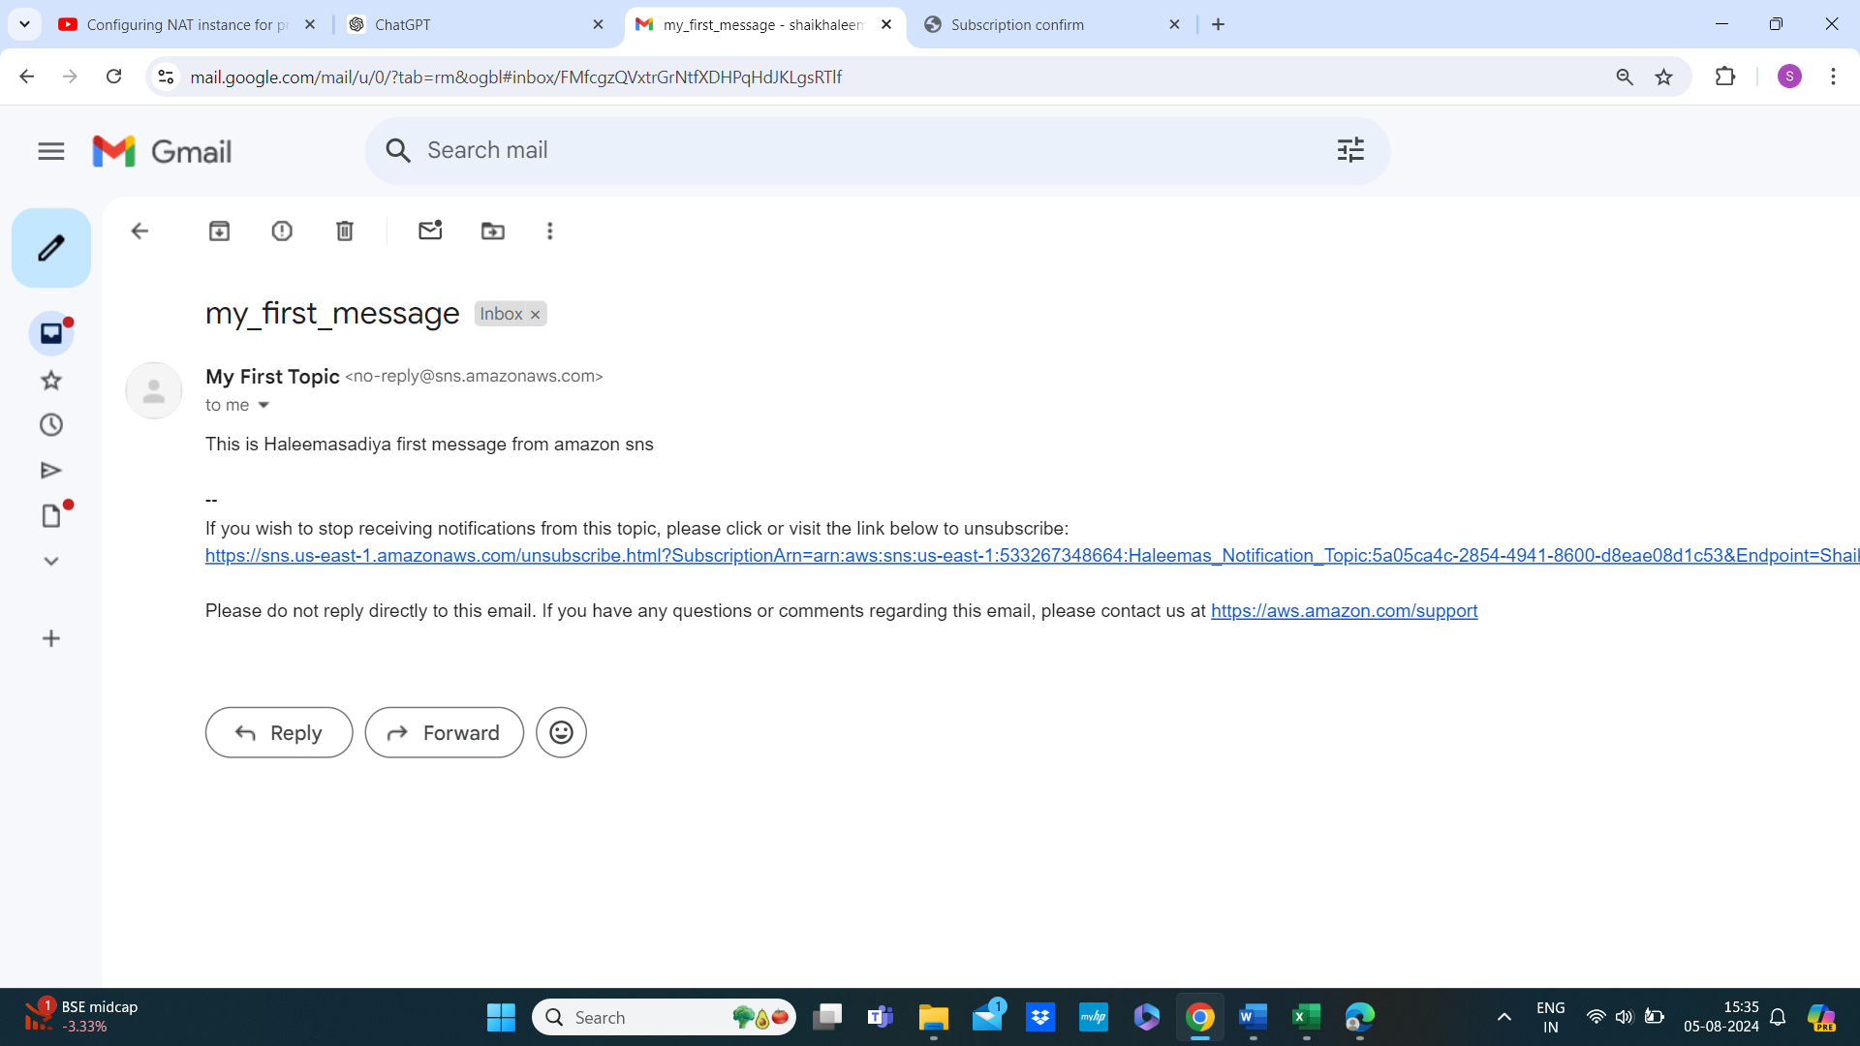

**Step 5: Cleanup**

1. **Delete Resources:**
   * Go to SNS and delete the topic you created.

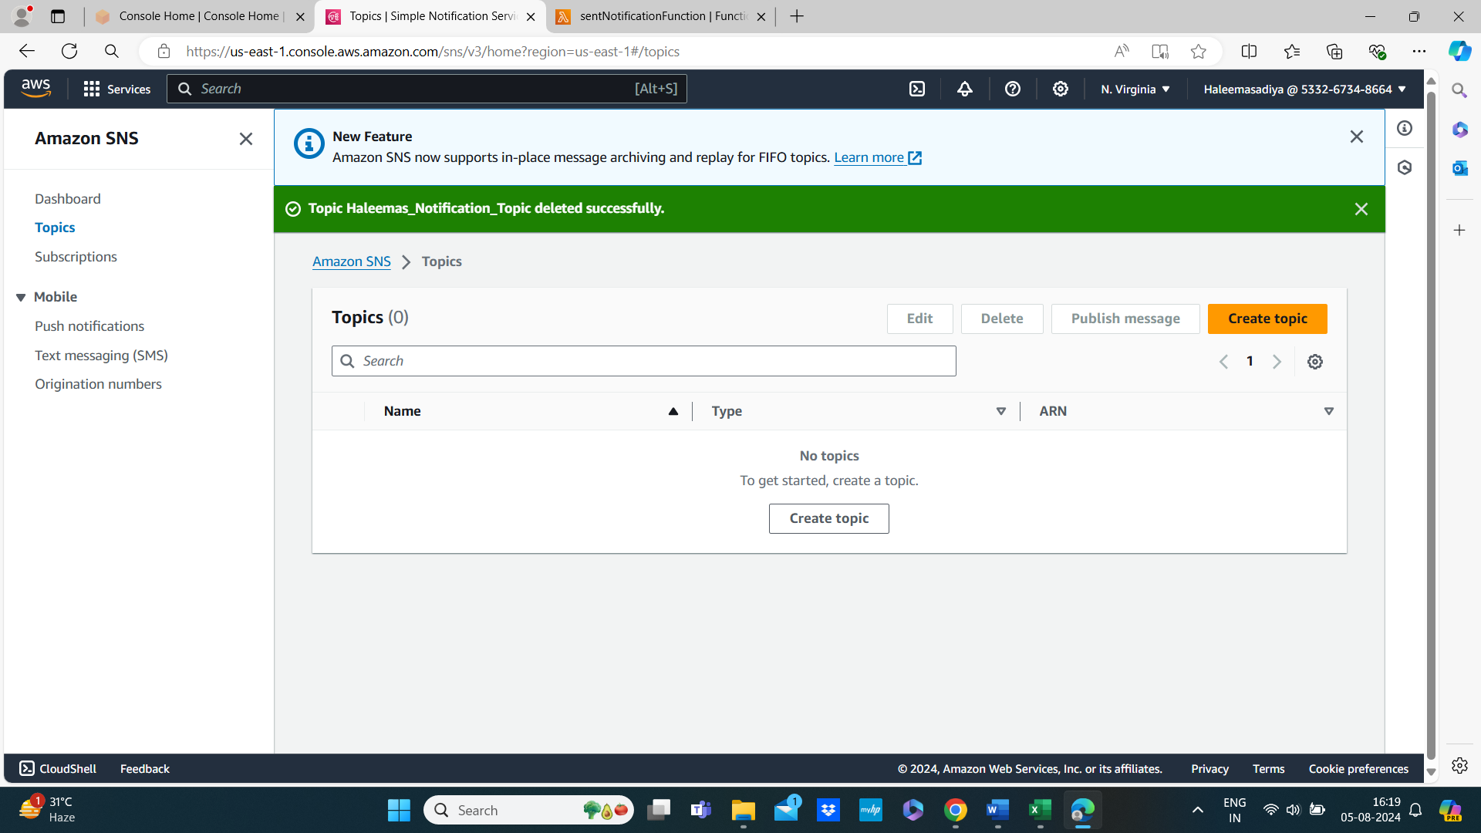

* + Ensure you also clean up any other resources you’ve created.

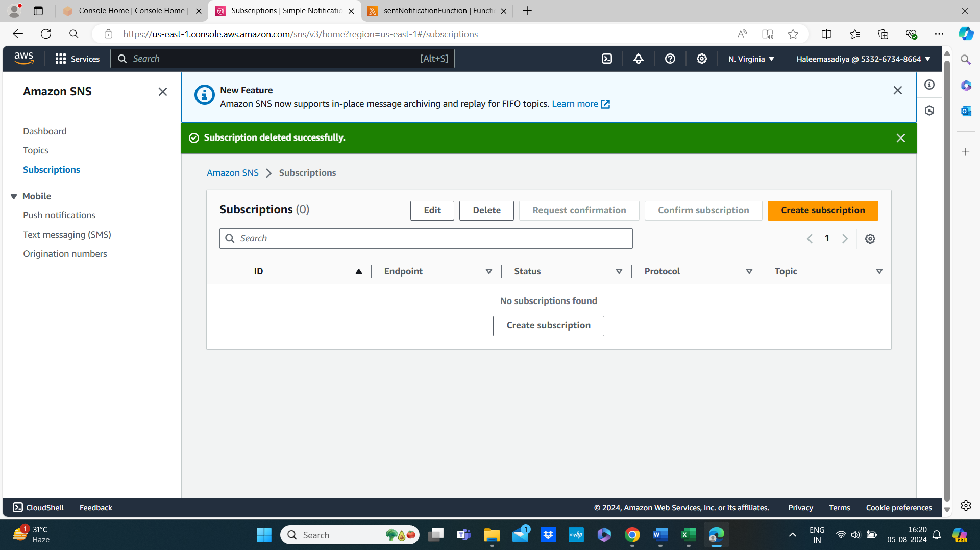

**Conclusion**

This mini project demonstrates the basic capabilities of AWS SNS, including creating topics, subscribing to them, publishing messages. We can expand this project by integrating it with other AWS services, such as S3, CloudWatch, or DynamoDB, to create more sophisticated notification systems.